Forum Urbes Medii Aevi IX
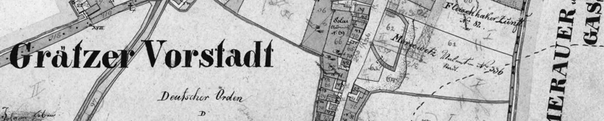
will take place on June 2–4, 2010
in Opava

Conference topic:

„Suburbs of medieval towns in Central Europe“

Preliminary guidelines for participants:

- Duration of particular lectures will be 20 min at the most.
- After each block of lectures there will be time for discussion.
- All lecturers will have the possibility of presentation on boards in vestibule.
- Presentation devices available: data projector, slide projector, overhead projector (in case of any other devices demanded, please let us know in advance).
- Conference languages: German, English, Czech, Slovak. The lectures will be consecutively interpreted.
- At least one social evening (to be specified).
- An excursion through interesting sites of the town of Opava.
- The paper is to be registered by April 30, 2010 at the latest.
- Any information will be continuously updated on our web site http://www.archaiabrno.org/home_cs/?

- By May 5, 2010 all the participants registered will obtain detailed guidelines including the current program.

Contact address:

Mgr. Soňa Mertová

ARCHAIA Brno o.p.s.

Česká 6, 602 00 BRNO
E-mail: smertova@archaiabrno.cz
Cell phone: +420 777 239 553
Tel: +420 545 214 069

