Forum Urbes Medii Aevi VIII
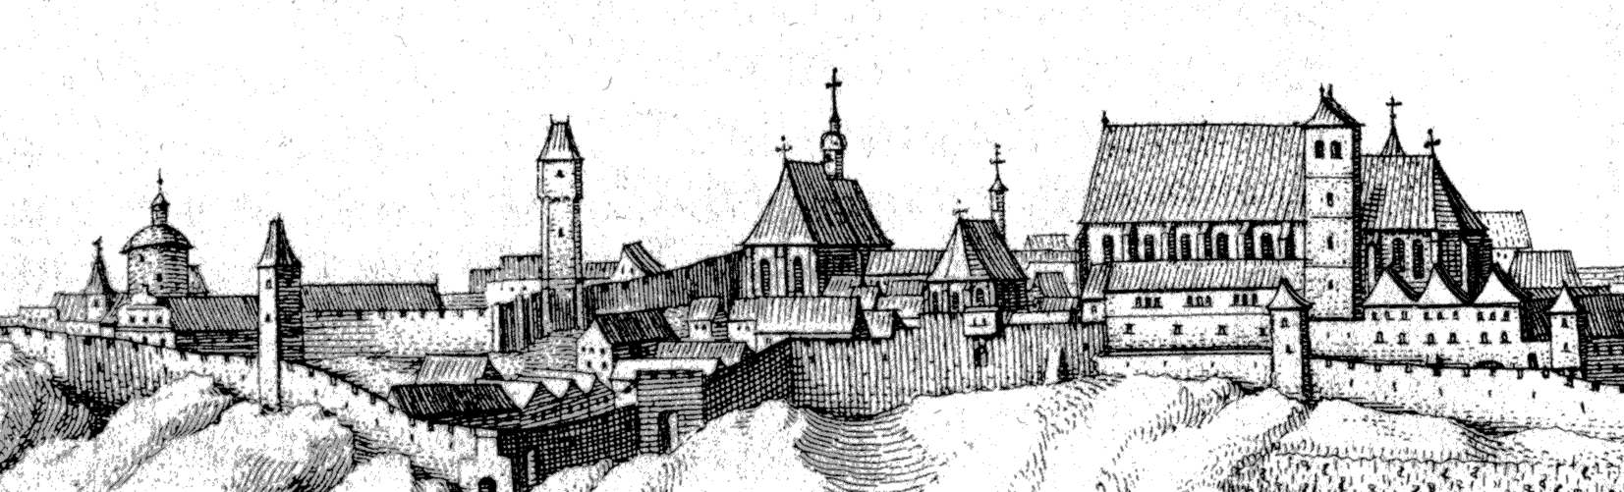
June 17-19, 2009

Znojmo – Redutní sál at the Beseda building in the Masarykovo náměstí 22 (square)

Conference topic:

„Parish churches, hospitals and cemeteries in the structure of high medieval town and early medieval agglomerations“

Guidelines for participants:

- Duration of particular lectures will be 20 min at the most.
- After each block of lectures there will be time for discussion.
- All lecturers will have the possibility of presentation on boards in vestibule.
- Presentation devices available: data projector, slide projector, overhead projector (in case of any other devices demanded, please let us know in advance).
- Conference languages: German, English, Czech, Slovak. The lectures will be consecutively interpreted.
- At least one social evening (to be specified).
- On every early evening an excursion will take place (to be specified)
- The paper is to be registered by March 31th, 2009 at the latest.
- Any information will be continuously updated on our web site http://www.archaiabrno.org/home_cs/?
- By April 10th, 2009 all the participants registered will obtain detailed guidelines including the current program.

Contact address:

Jitka Šibíčková
ARCHAIA Brno o.p.s.

Česká 6, 602 00 BRNO
E-mail: jsibickova@archaiabrno.cz
Cell No: +420 777 239 331
Phone: +420 545 214 069

